**Phase 6 – Lightning App Setup and Customization**

This phase focuses on creating a **dedicated Lightning App** for internship management and customizing the record pages for better usability. The steps ensure that users have a structured navigation experience and quick access to related data.

**Step 1: Create the Lightning App**

1. Navigate to **Setup → App Manager**.
2. Click **New Lightning App**.
3. Provide the following details:
   * **App Name**: Smart Internship & Placement System
   * **Developer Name**: Auto-filled (leave default).
   * **Description**: *The Smart Internship & Placement Management System is a Salesforce-based solution designed to streamline the internship and campus placement process for educational institutions. The system automates student applications, enables company HR approvals***App Branding**: Select a colour and logo if desired.
4. Click **Next** to proceed.  
     
   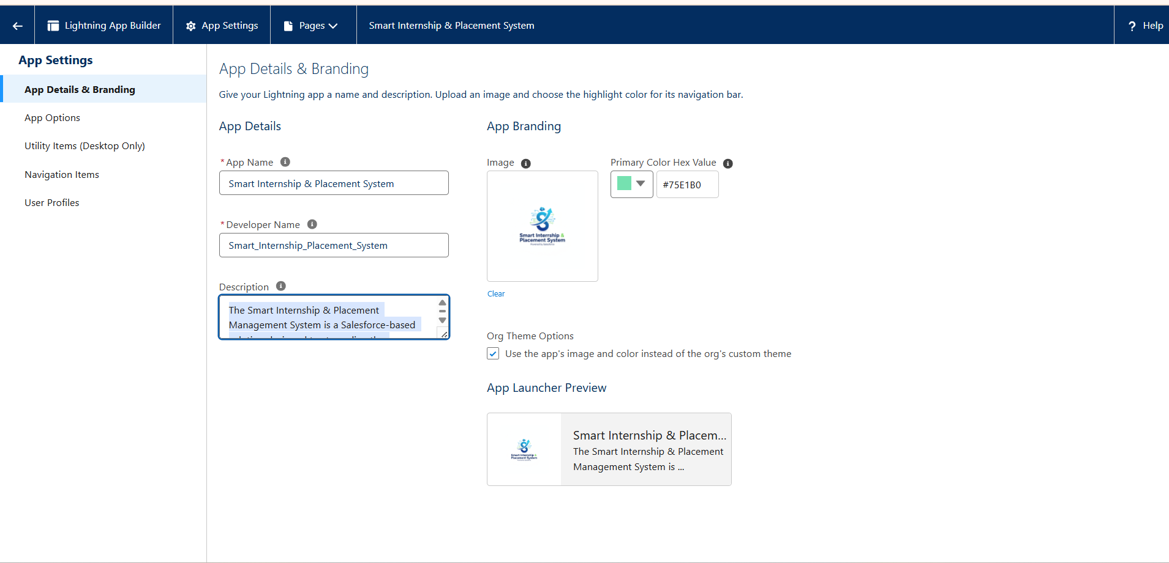

**Step 2: Add Tabs to the App**

1. In **App Options → Navigation Items**, click **Add More Items**.
2. Add the following objects as tabs:
   * Student
   * Company
   * Internship
   * Application
   * Feedback
3. Reorder the tabs if required for better navigation.
4. Click **Next** to continue.  
     
   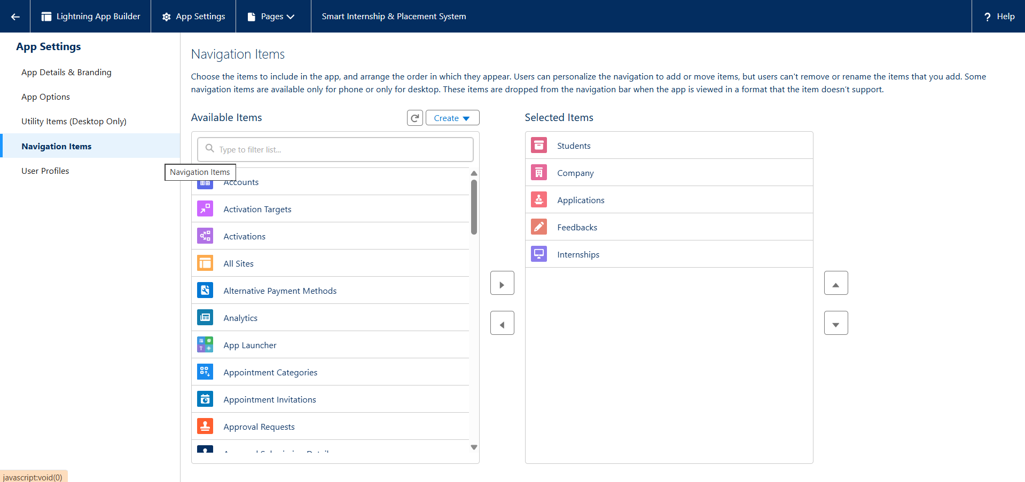

**Step 3: Assign App to Profiles**

1. Choose the profiles that should have access to this app.
   * For initial setup, assign it to **System Administrator, HR , Student , Placement Officer**.
2. Click **Next → Save & Finish**.

**Step 4: Customize Lightning Record Pages**

1. Open any object record (e.g., Student).
2. Click the **Gear Icon → Edit Page**.
   * This will launch the **Lightning App Builder**.
3. Customize the page by dragging and adding components:
   * **Student**: Add Related Lists for *Applications* and *Feedback*.
   * **Internship**: Add Related List for *Applications*.
   * **Company**: Add Related List for *Internships*.
   * **Application**: Add related components as required.
   * **Feedback**: Configure as needed.
4. Click **Save → Activation**:
   * Select **Org Default** to make it visible to all users.
5. Repeat the above steps for **Student, Company, Internship, Application, and Feedback** record pages.  
     
     
     
   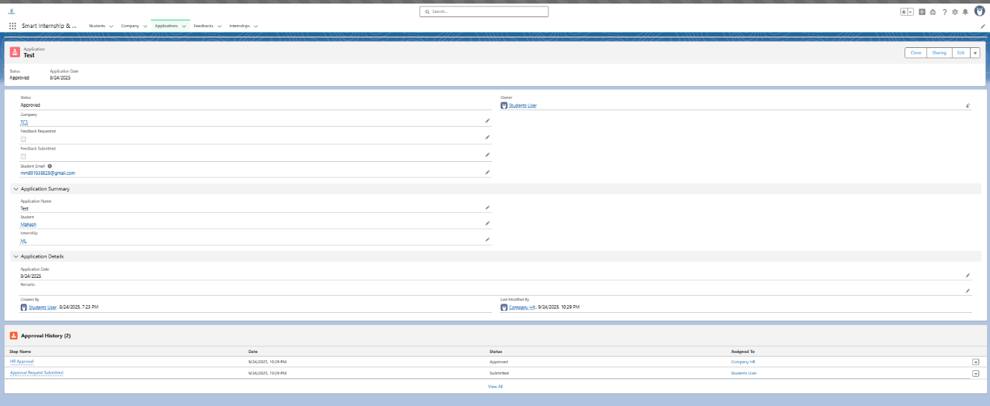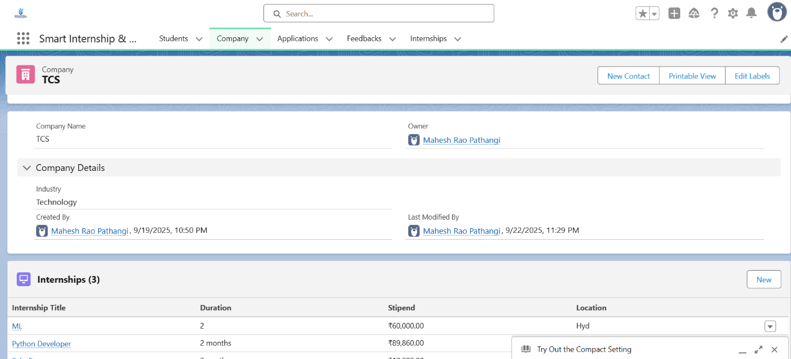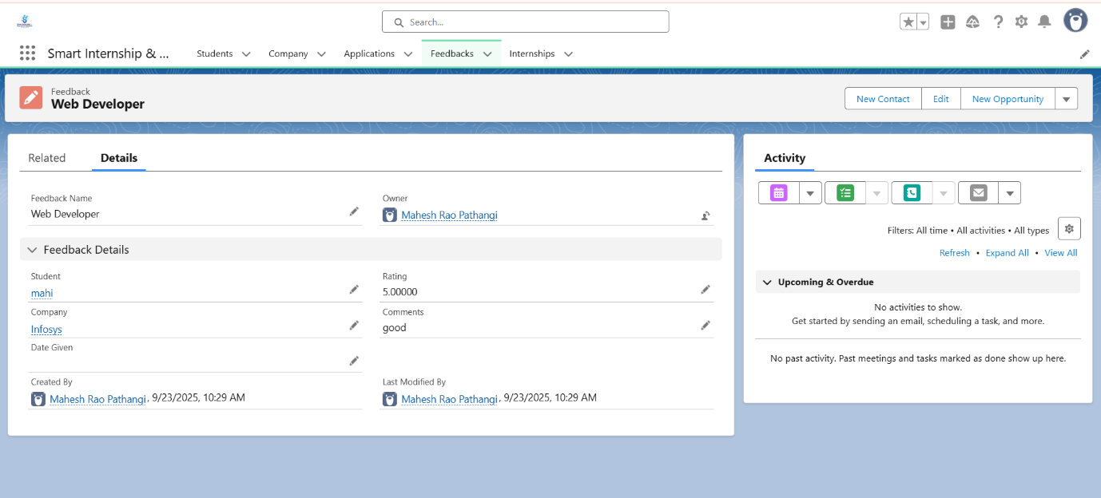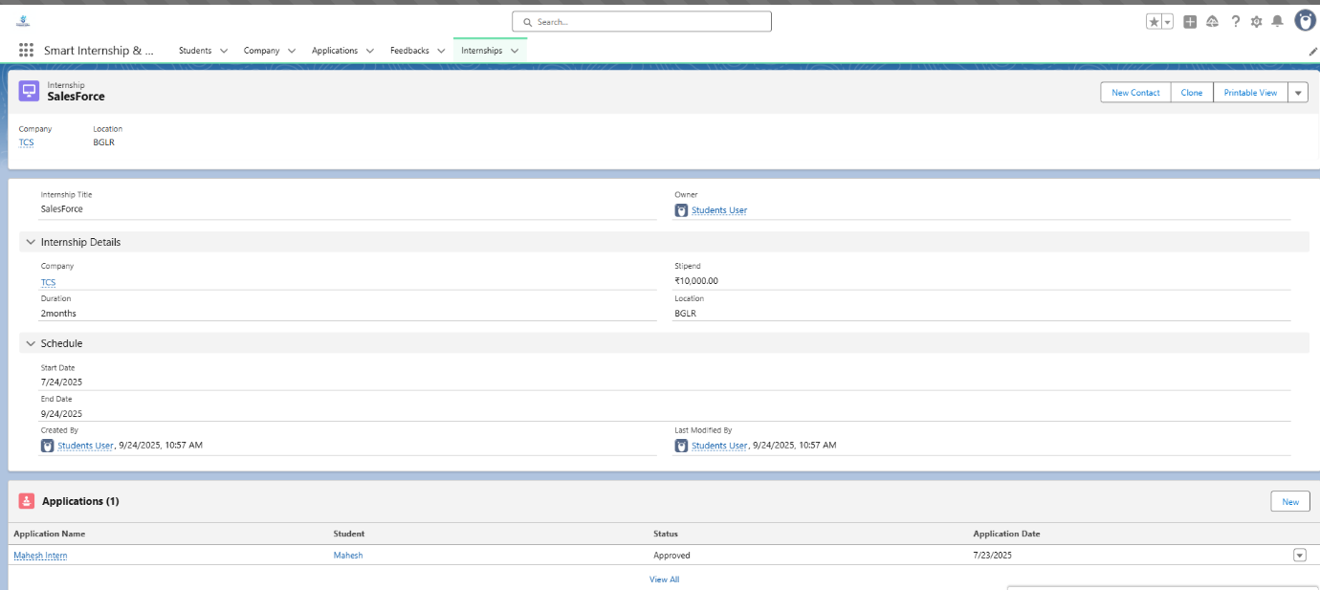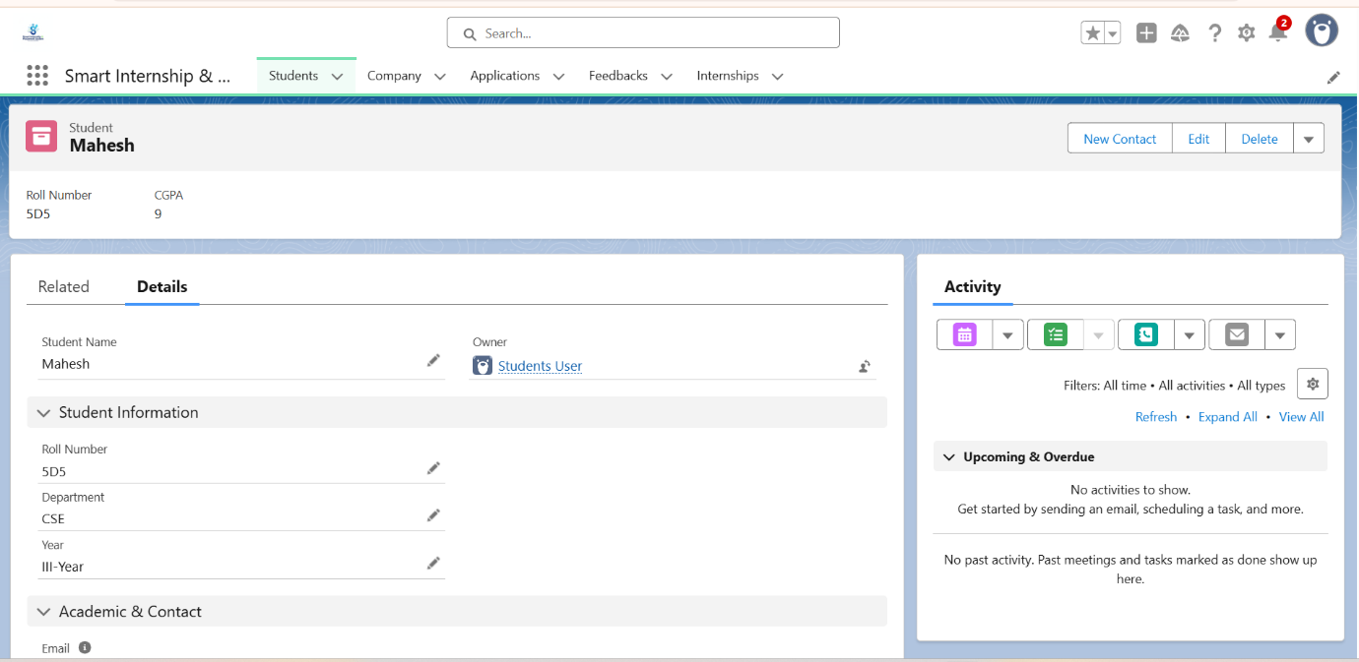

**Outcome of Phase 6:**

* A centralized **Internship Management Lightning App** is available.
* All required tabs (Student, Company, Internship, Application, Feedback) are included.
* Each record page is tailored to display **related data** for easy navigation and usability.